To: All TRIUMPH Suppliers October 2022
As we end Q2 of TRIUMPH’s Fiscal Year 2023, we first want to thank all our suppliers for their continued efforts to take on today’s supply chain challenges and work collaboratively with all our sites in the spirit of our “one company, many solutions” operating philosophy.
TRIUMPH has pivoted from On-Time-Delivery (OTD) to On-Time-In-Full (OTIF) to assure our suppliers provide our total demand within the delivery timing. A comparison is noted below:
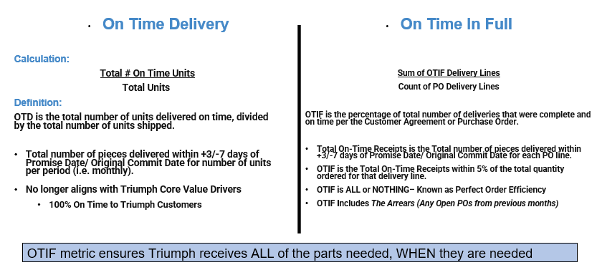
Your Supplier OTIF result is reflected in the portal (http://www.triumphsupplysource.com) and on the supplier scorecards which are now being distributed automatically to the supplier email addresses noted within the supplier portal. Each Supplier should assure that their supply chain and quality contact emails are current and that the following email is in your safe senders list: QlikProdNPrinting@triumphgroup.com
The supplier scorecards will also reflect the new weighted risk scoring. Previously risk levels were heavily Quality focused, going forward, the new weighted risk score now includes five 6-month rolling KPI’s (OTIF, Business Impact, NOE Count, Quality Yield and eSCAR’s). As we change our risk management philosophy from program based to that of operational risk and resilience, we are also adding six operational risks that will be reflected on your scorecards in CY Q4: Operations, Geopolitical, Finance, Cybersecurity, Restrictions, Environmental Social Governance (ESG). More communications will be forthcoming in the coming months.
This month, Triumph is also updating our Supplier Quality Assurance Manual (SQAM) to align with the above-mentioned changes as well as clarification to the supplier chargeback process. Supplier non-conformance data is being recorded in our supplier portal to calculate the cost of poor quality (COPQ). TRIUMPH will determine if we need to impose administrative charges or other measures. This effort is in no way to penalize our supply base but to drive the right quality behaviour.
We look forward to continuing collaboration and regular supplier communications as well as bring to your attention any/all specific program risks, to allow “joint problem solving” to ensure that we stay focused on supplier risk management.
We thank you for being a committed supplier to TRIUMPH and our customers. Together, we will TRIUMPH as One Team.
Colin O’Mahoney Deb Trailor
Colin O’Mahoney, VP Supply Chain Deb Trailor, Director Supplier Performance

TRIUMPH 899 Cassatt Rd, Ste 210, Berwyn, PA 19312 | Tel: 610.251.1000 Fax: 610.251.1555 | email@triumphgroup.com

